**Artwork**

**Concept Drawings**

**Initial Game Concept Idea (scrapped)**

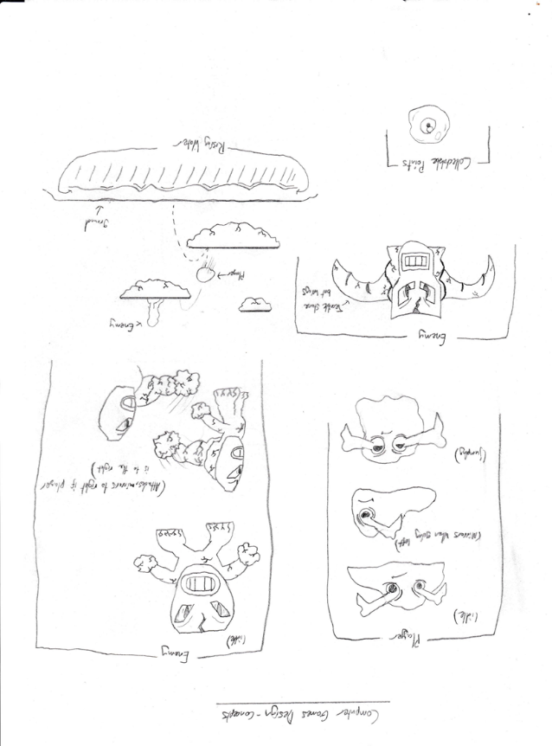

**Initial Game Concept Idea- Envisioning the World**

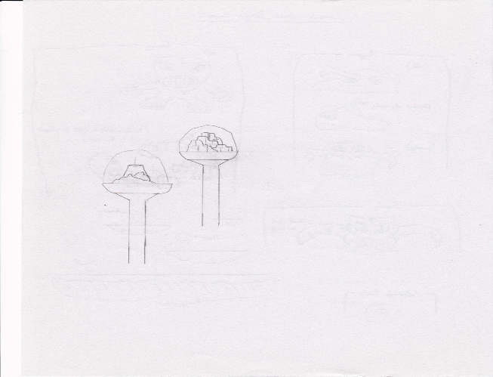

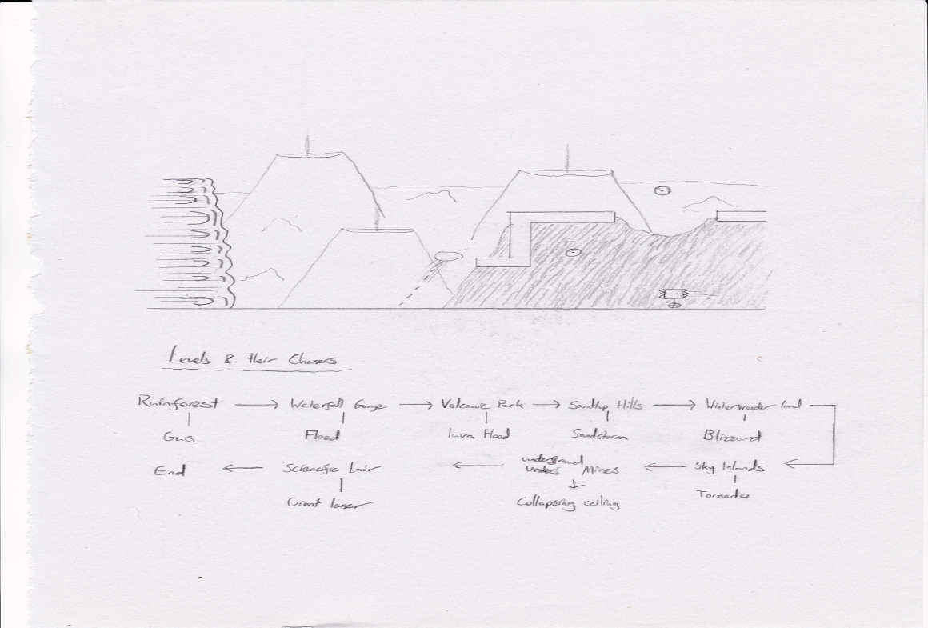**Game Concept idea – Imagining gameplay / world looks**

**Game Concept idea – Enemies 1**

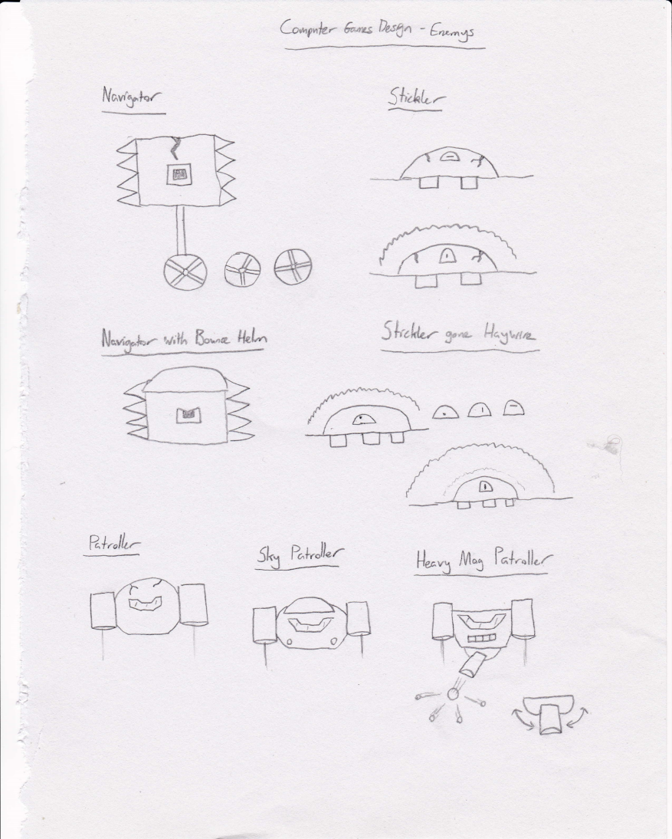

**Game Concept idea – Enemies 2**

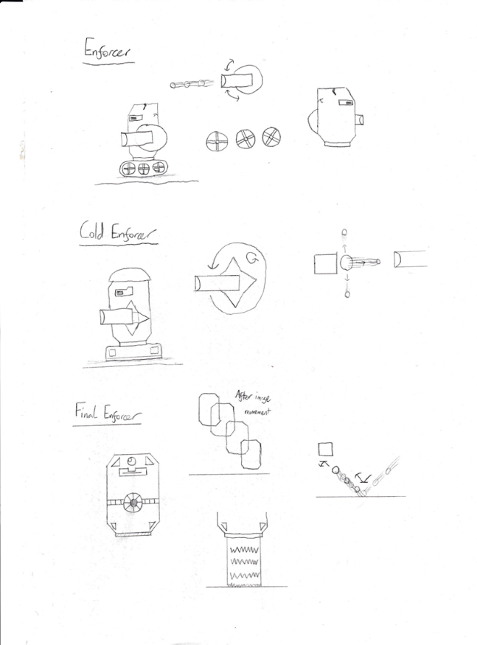

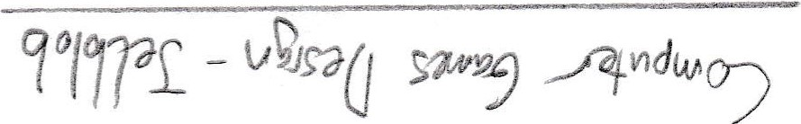**Game Concept idea – Player (Jelblob)**



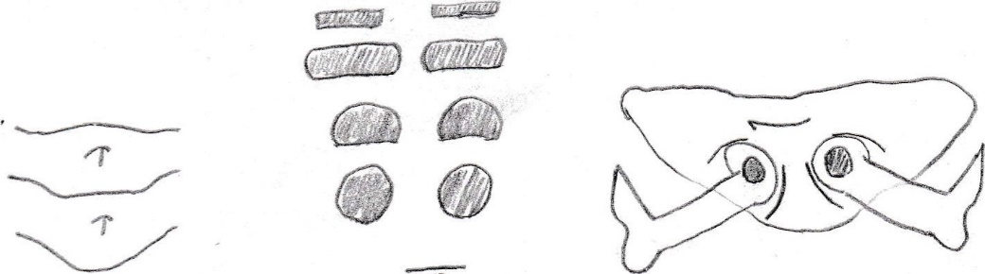

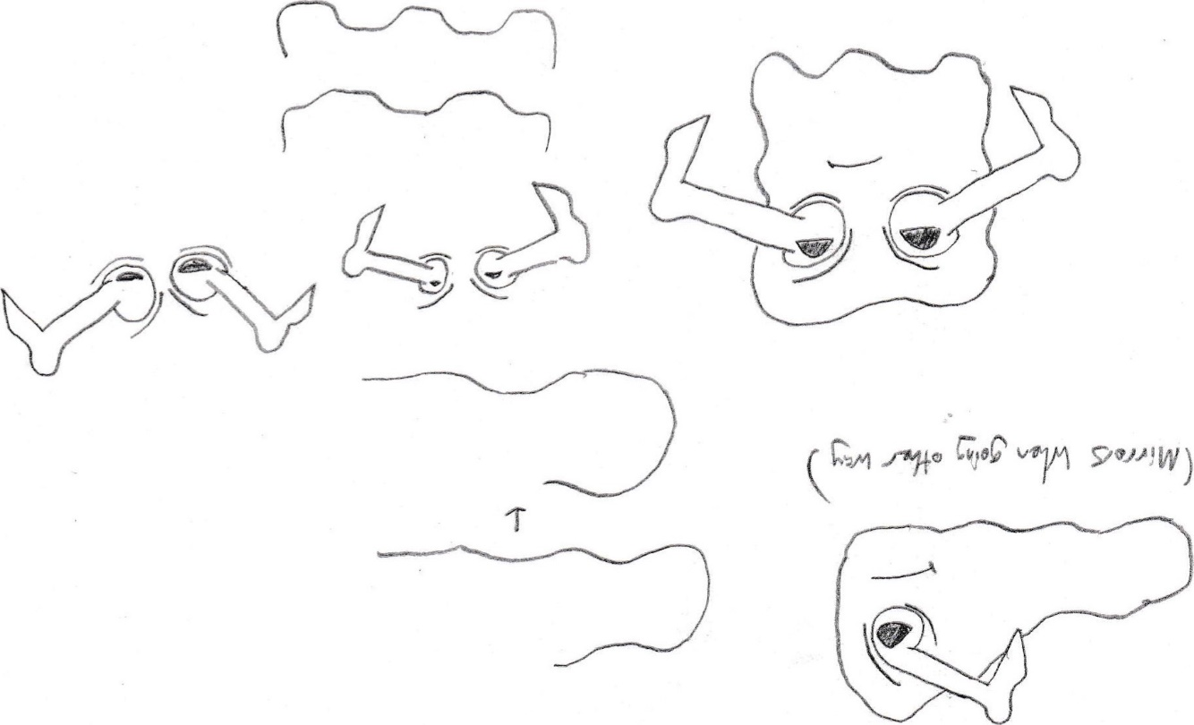

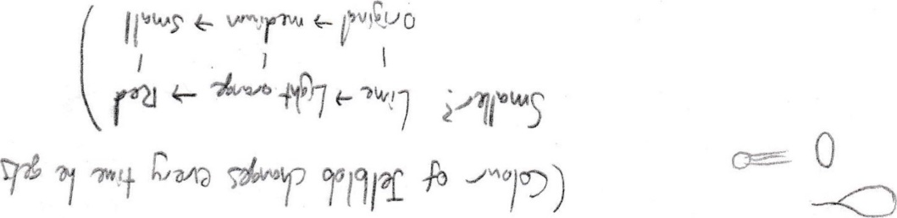

**Game artwork**

**Blocks**

**LavaLevelGroundBlock1 LavaLevelGroundBlock2**

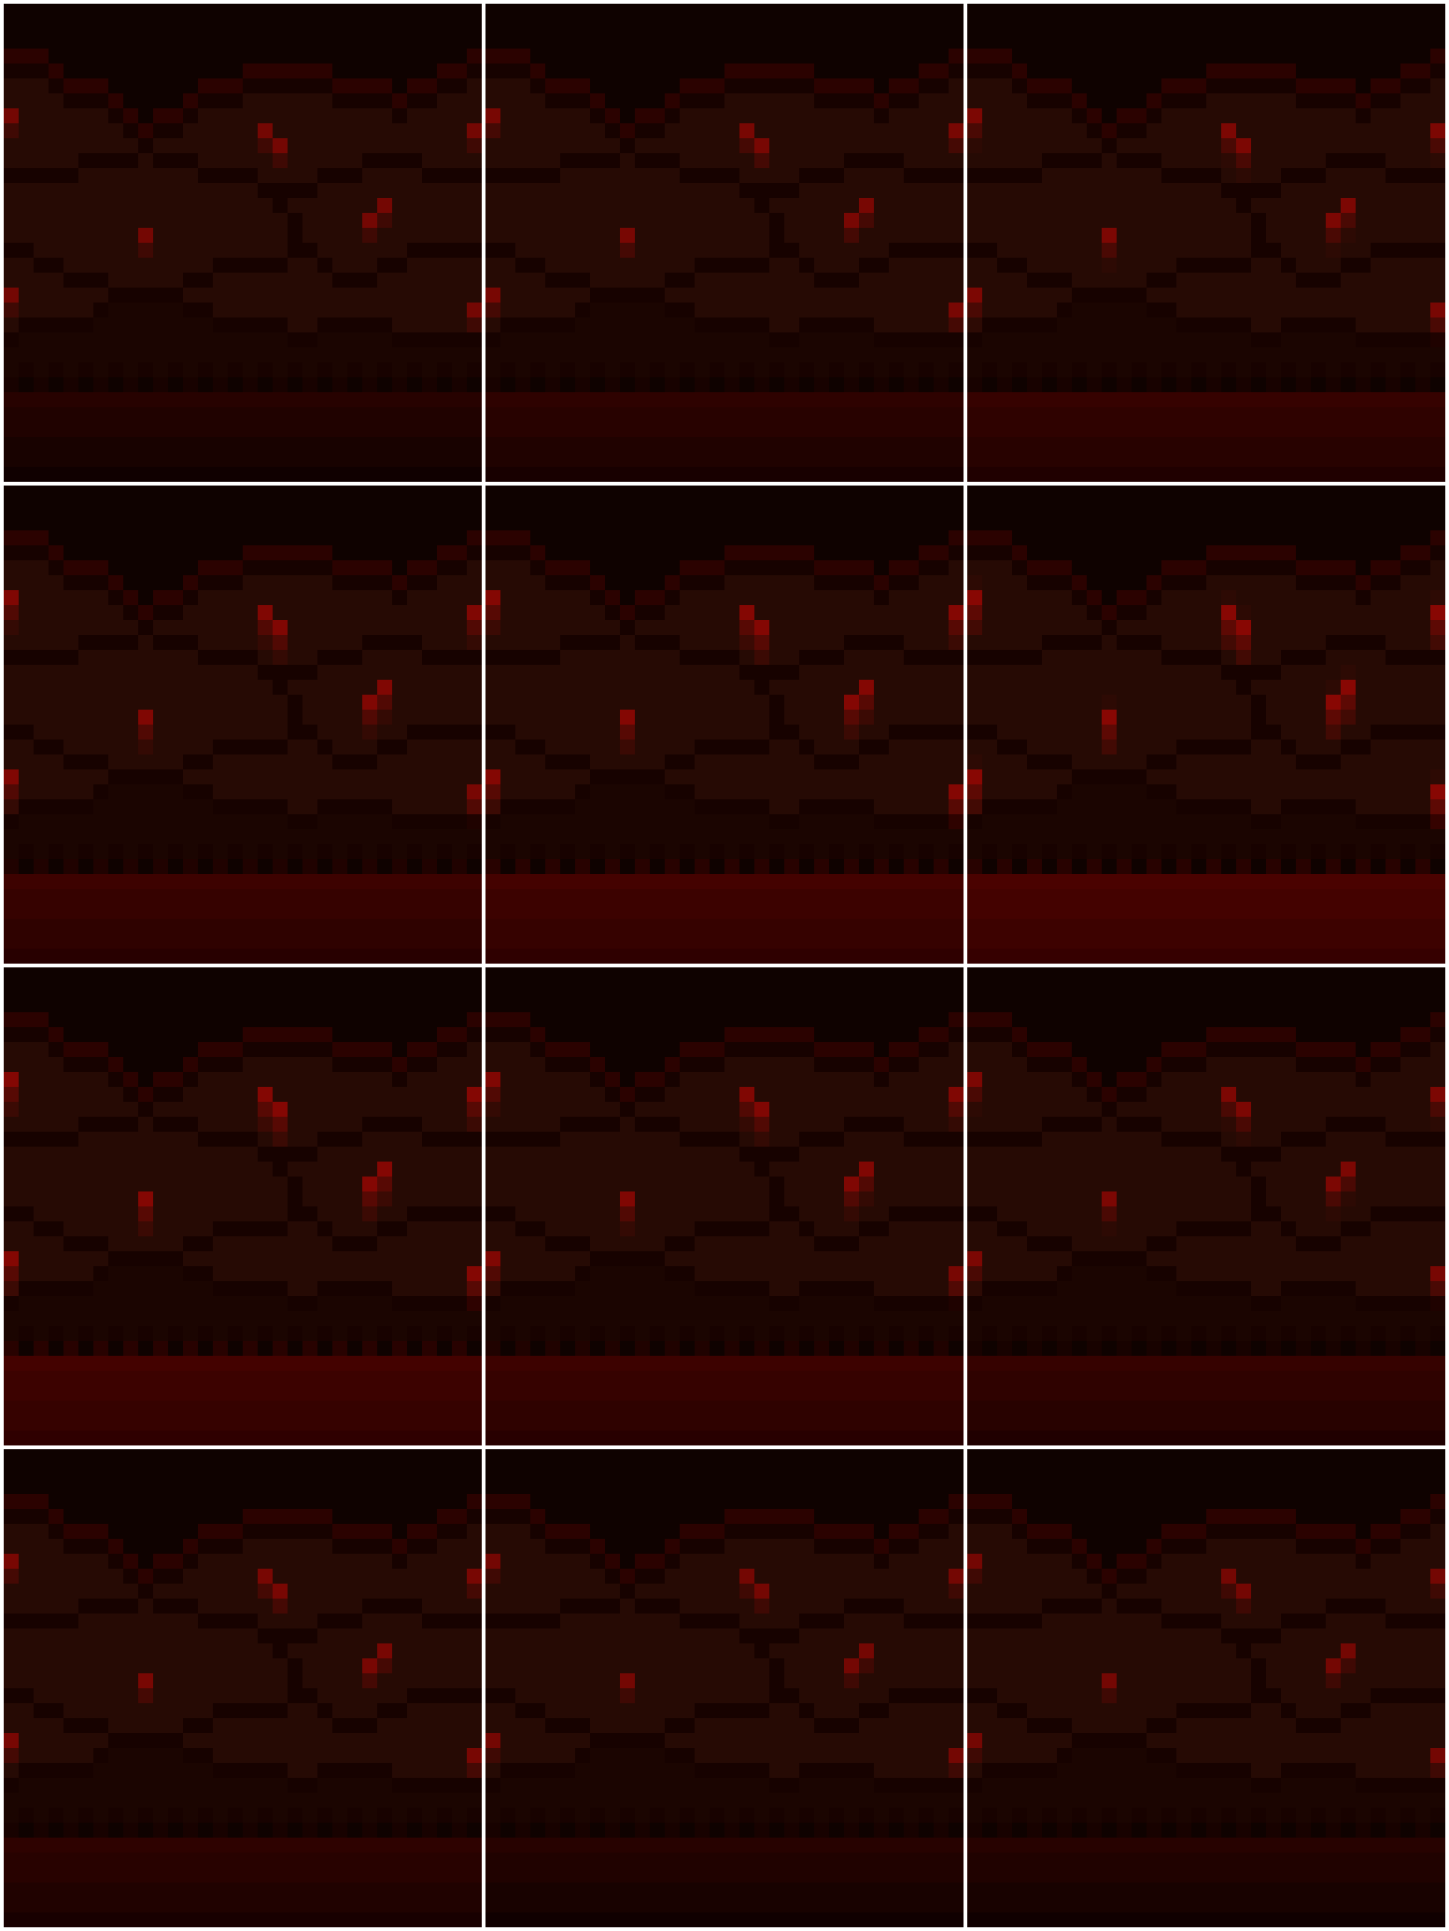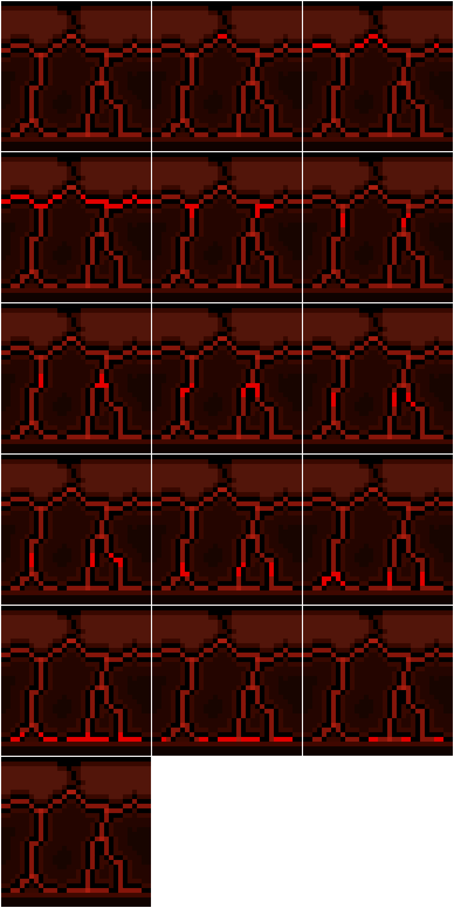

**LavaLevelGroundBlockEnd1**

**LavaLevelGroundBlockEnd1 LavaLevelGroundBlockEnd2**

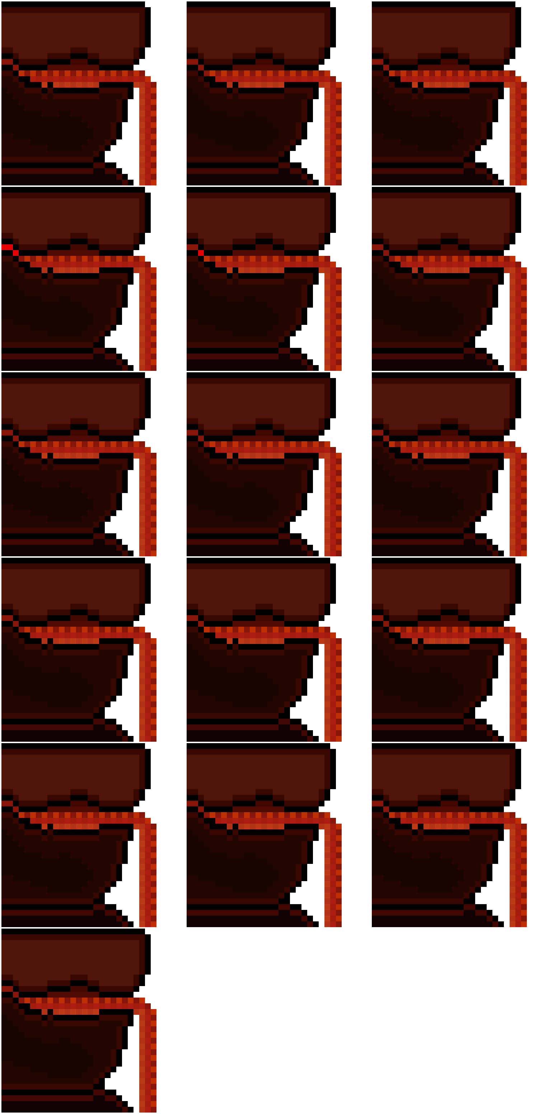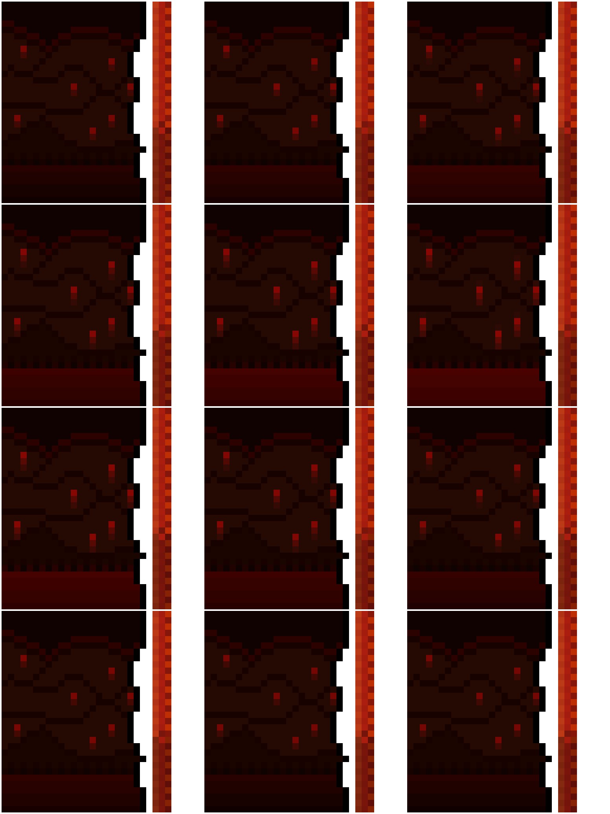

**LavaLevelFlyingBlock1**

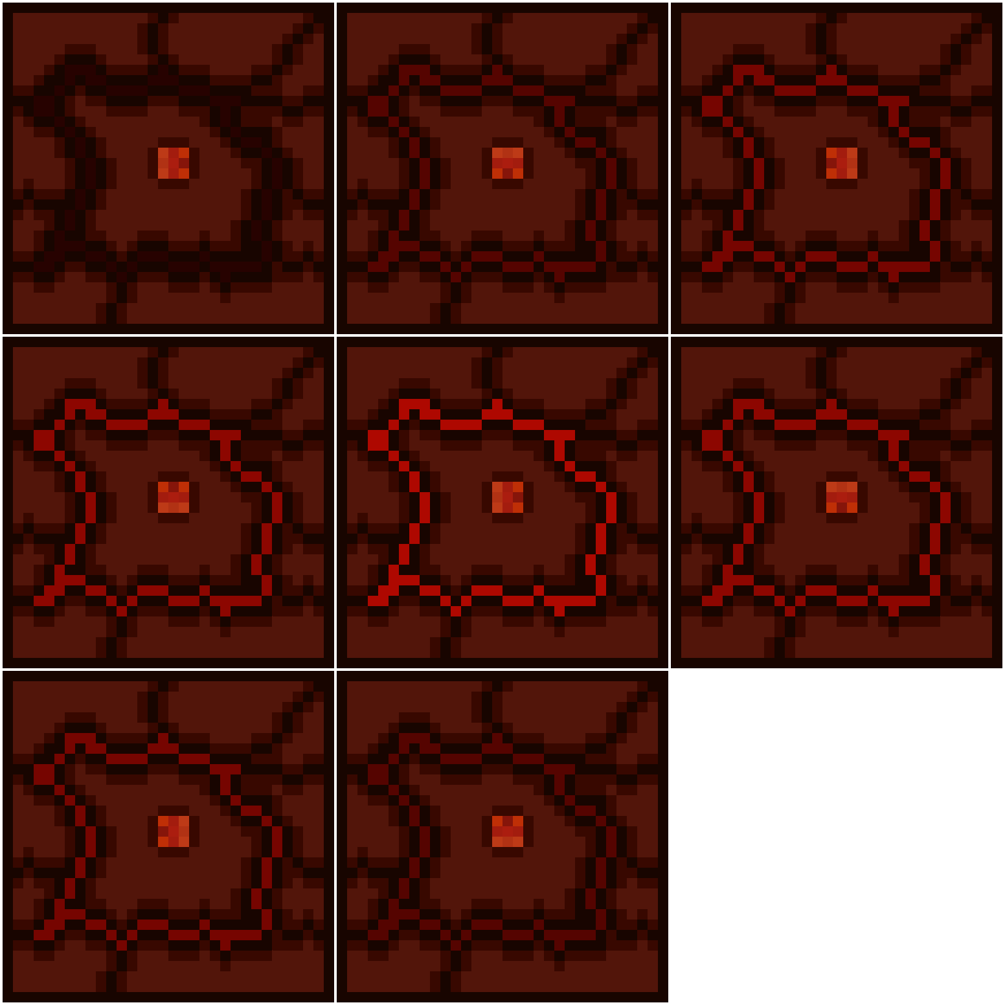

**LavaLevelDeathWall LavaLevelLavaGyser**

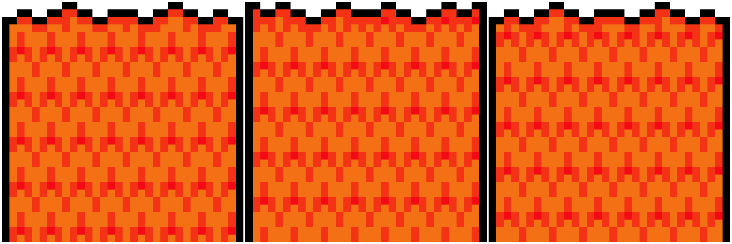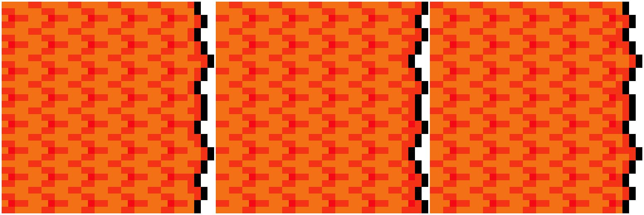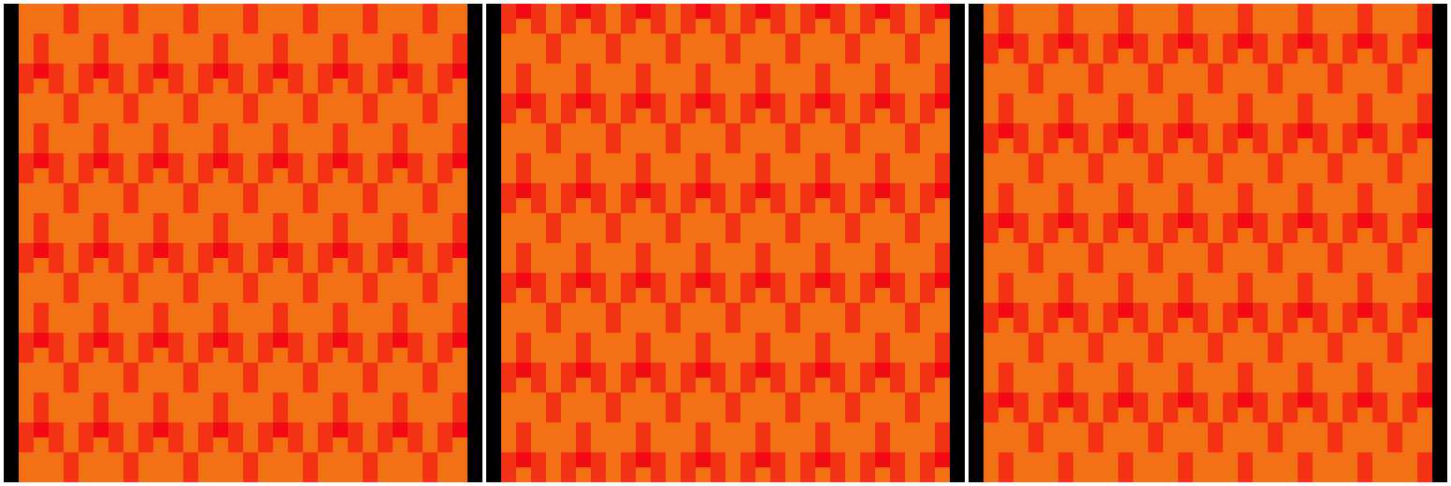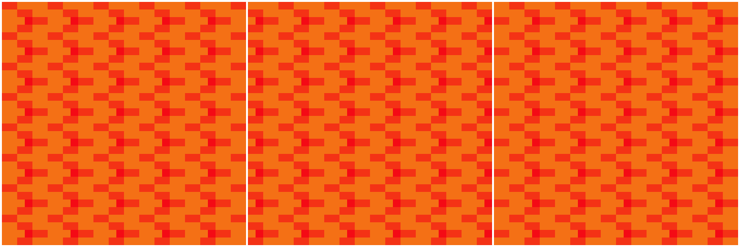

**LavaLevelMovingPlatform**

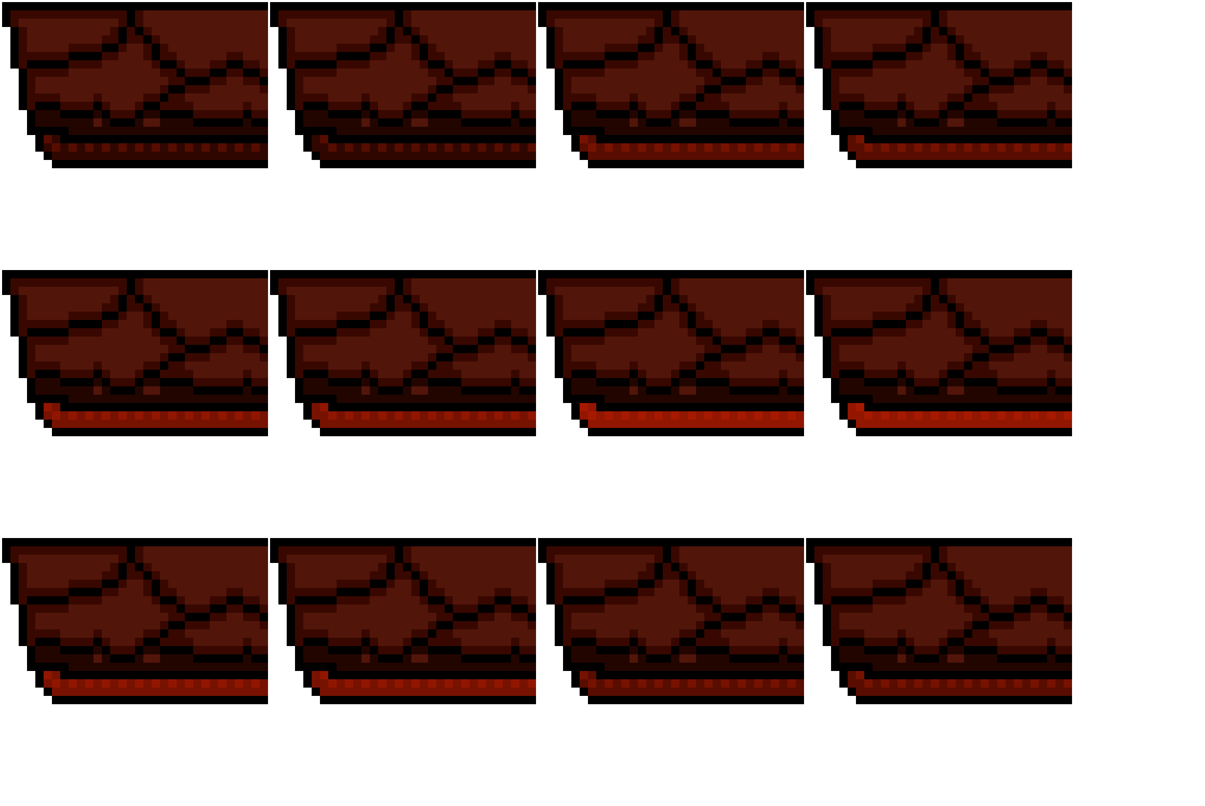

**LavaLevelSlippyBlockMid LavaLevelSlippyBlockEnd**

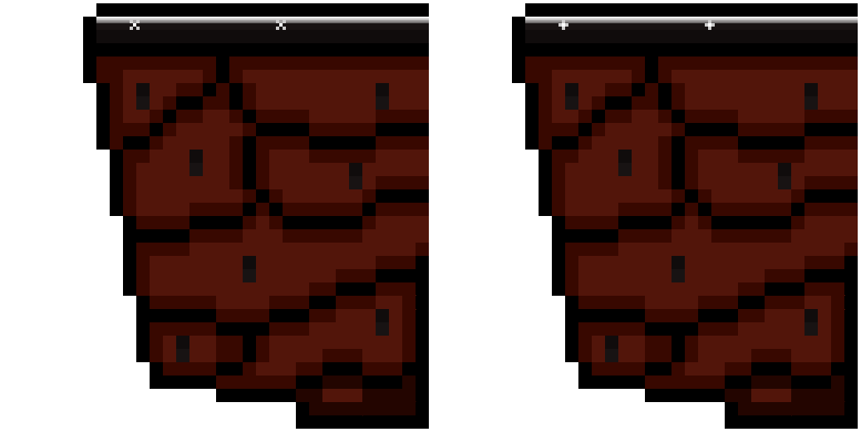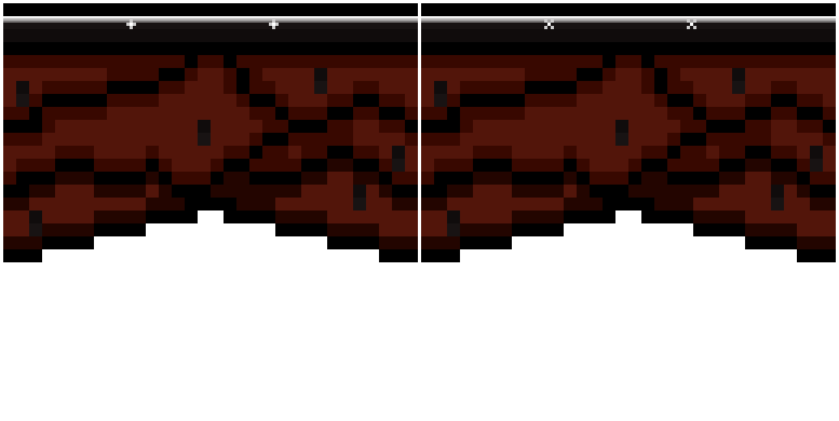

**LavaLevelUnstableGround**

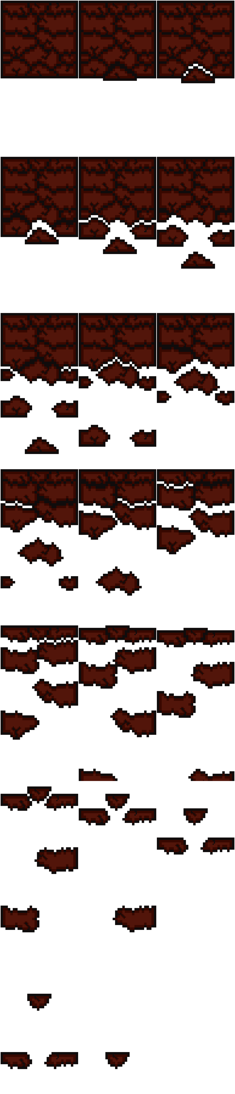

**Character**

**Jelblob**

**Enemies**

**Navigator Navigator with Helm**

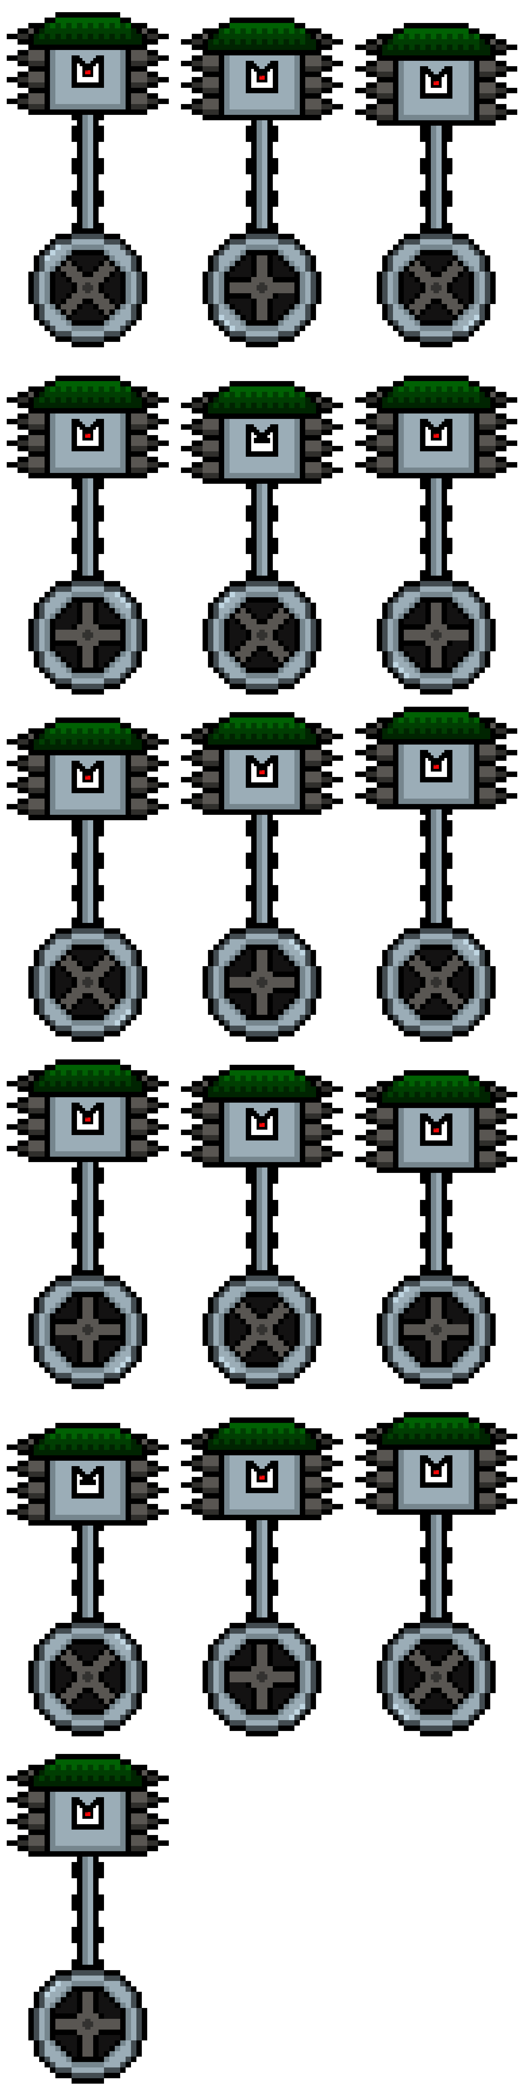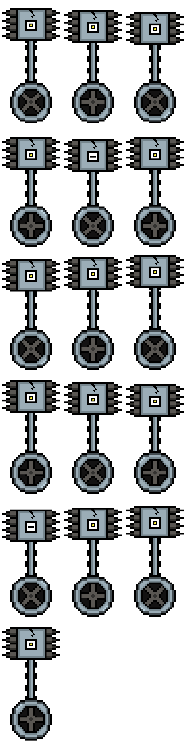

**Stickler Stickler gone Haywire**

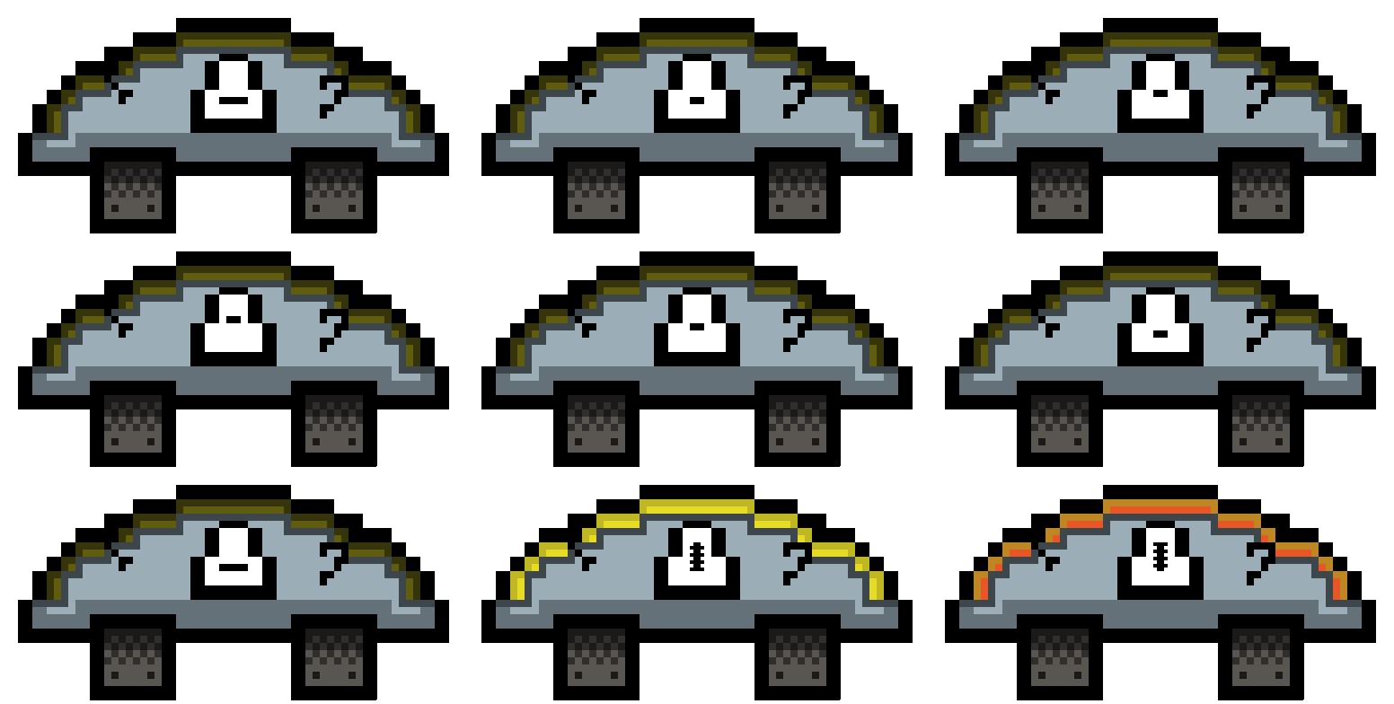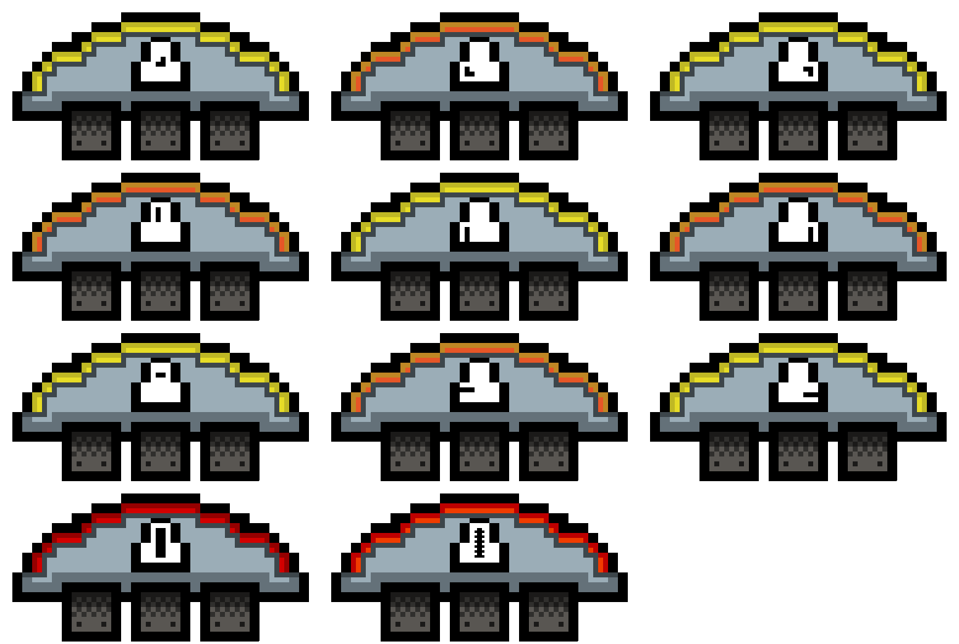

**Patroller Sky Patroller**

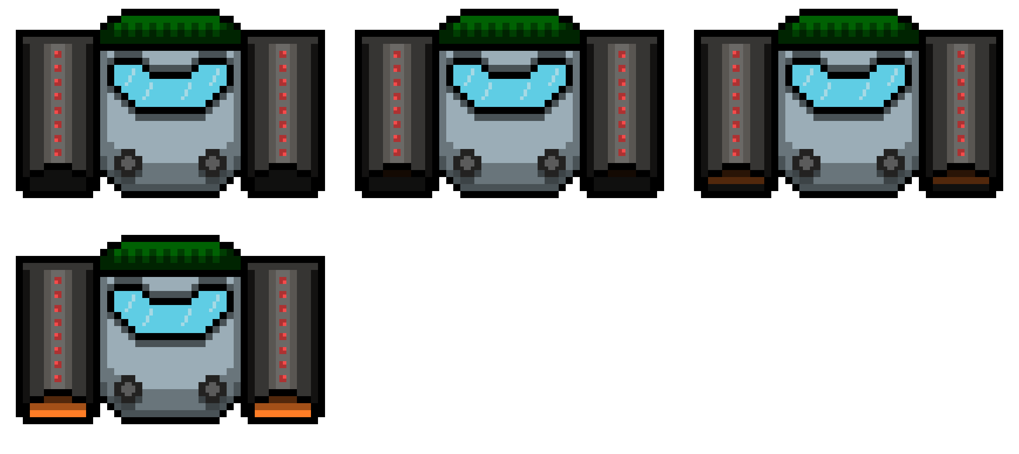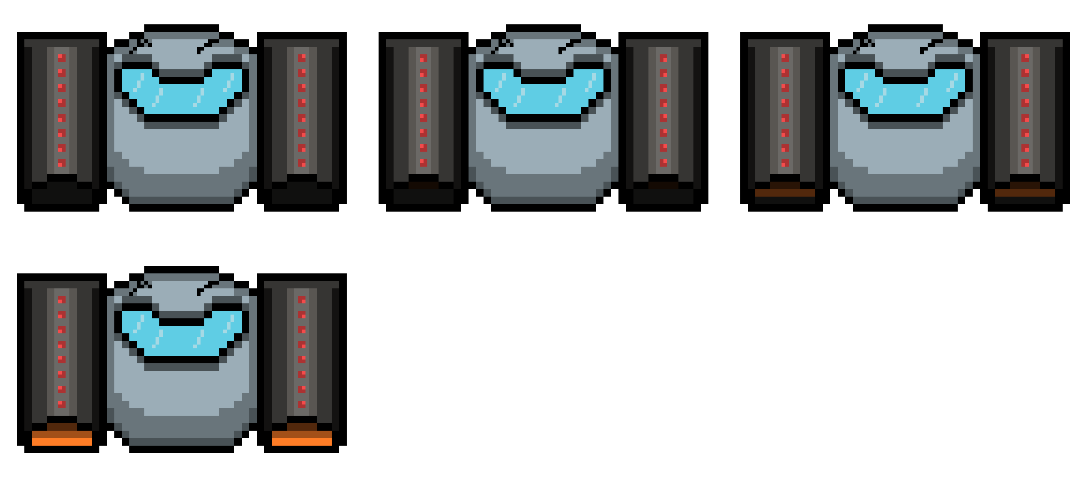

**Heavy Mag Patroller**

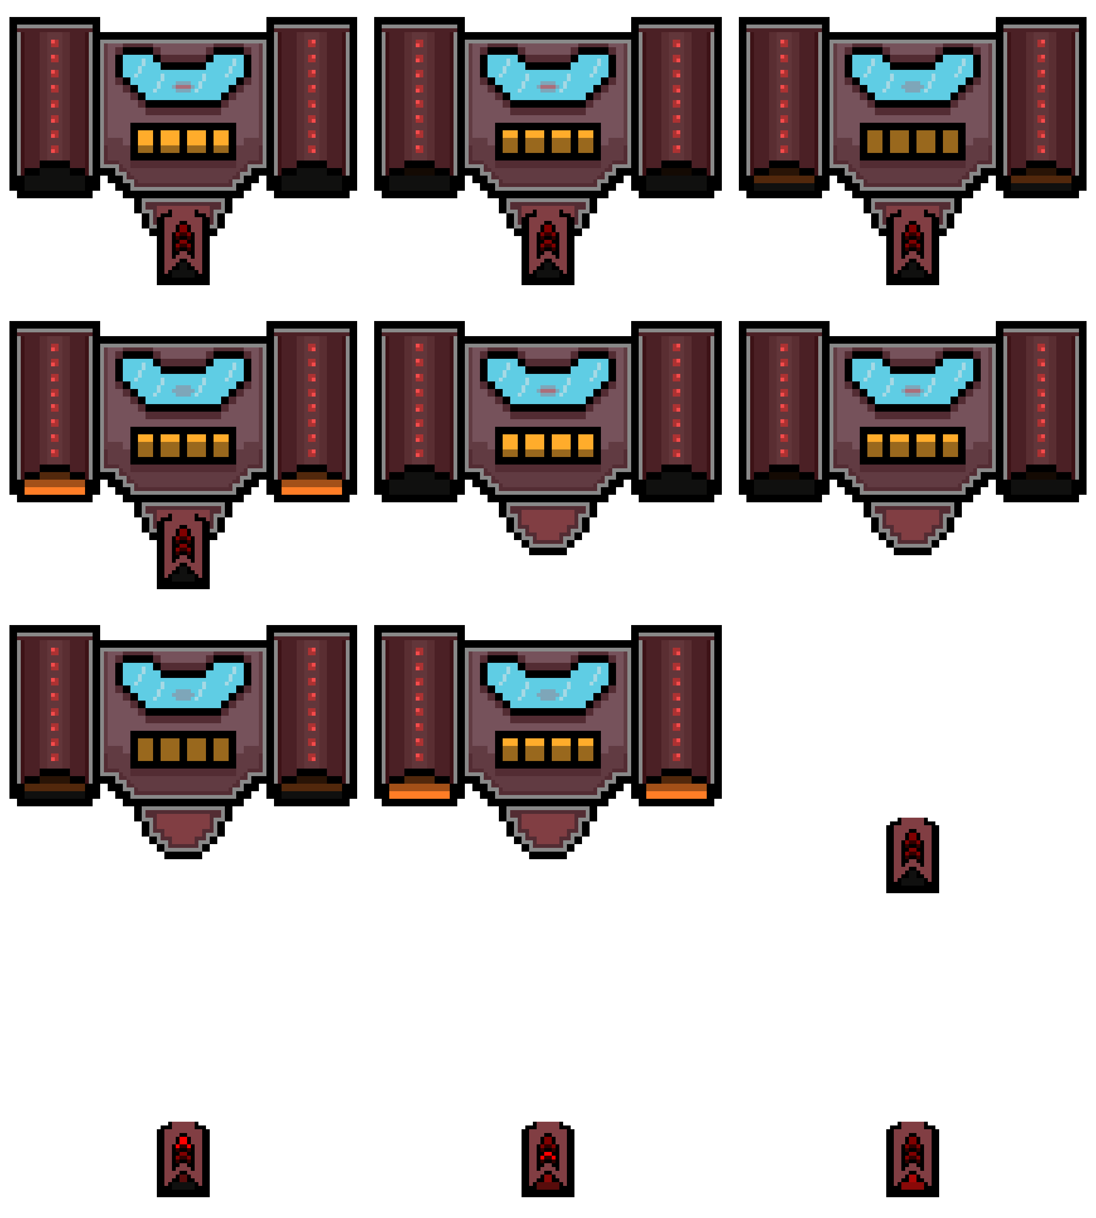

**Enforcer**



**Cold Enforcer**

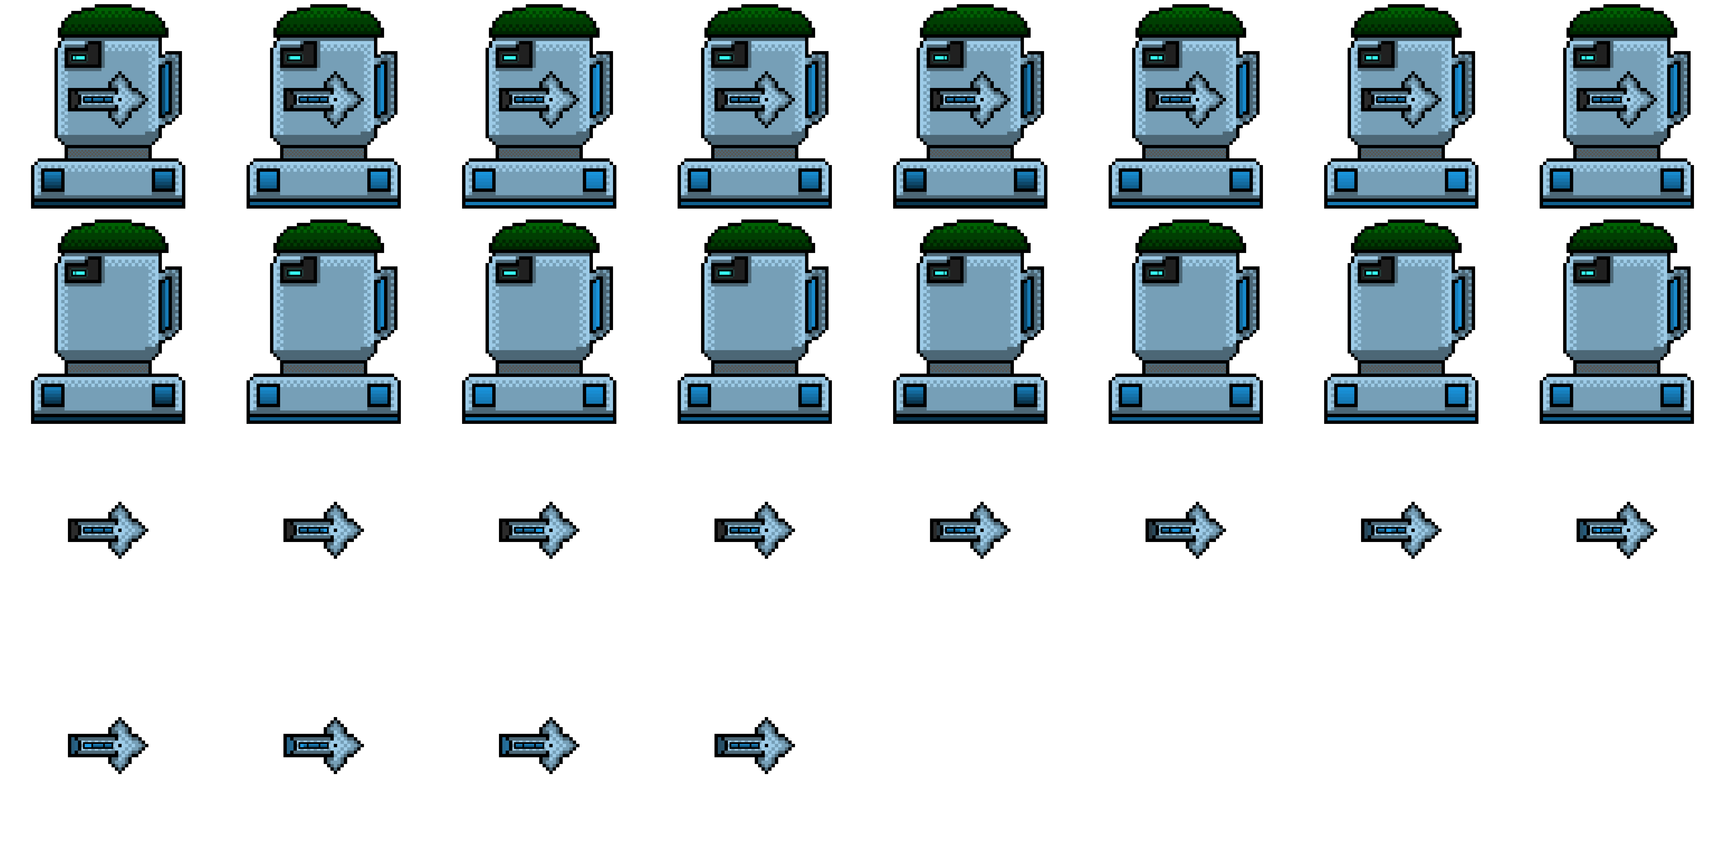

**Final Enforcer**

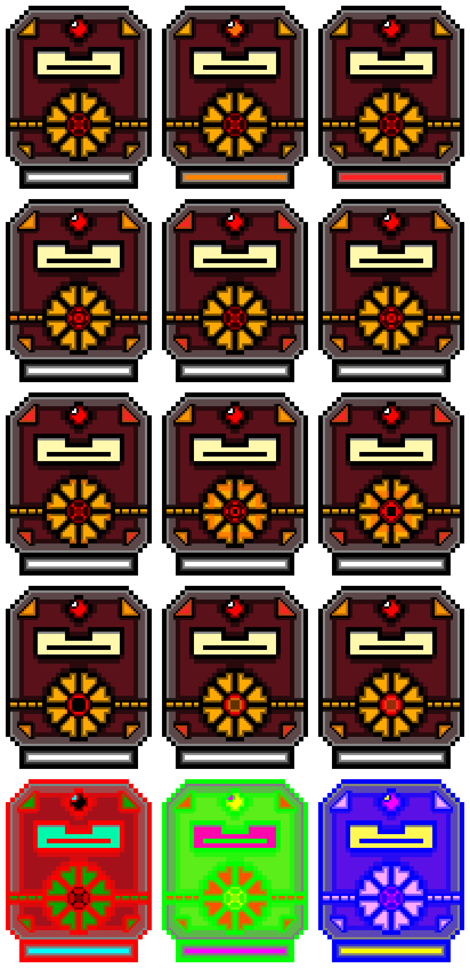

**Unused Assets**

**LavaLevelGround**



**Multimedia catalogue**

|  |  |  |
| --- | --- | --- |
| **Sprite / Image / Texture** | **Information** | **Filename** |
|  |  |  |
|  | A texture sprite block that was created with the use of the program, “Aseprite”, it is used as the top layer of the ground for the Lava Level. | **LavaLevelGroundBlock1_Enlarged1.png**  **LavaLevelGroundBlock1_Enlarged2.png**  **LavaLevelGroundBlock1_Enlarged3.png**  **LavaLevelGroundBlock1_Enlarged4.png**  **LavaLevelGroundBlock1_Enlarged5.png**  **LavaLevelGroundBlock1_Enlarged6.png**  **LavaLevelGroundBlock1_Enlarged7.png**  **LavaLevelGroundBlock1_Enlarged8.png**  **LavaLevelGroundBlock1_Enlarged-sheet.png** |
|  | A texture sprite block that was created with the use of the program, “Aseprite”, it is used as the bottom layer of the ground for the Lava Level. | **LavaLevelGroundBlock2_Enlarged1.png**  **LavaLevelGroundBlock2_Enlarged2.png**  **LavaLevelGroundBlock2_Enlarged3.png**  **LavaLevelGroundBlock2_Enlarged4.png**  **LavaLevelGroundBlock2_Enlarged5.png**  **LavaLevelGroundBlock2_Enlarged6.png**  **LavaLevelGroundBlock2_Enlarged7.png**  **LavaLevelGroundBlock2_Enlarged8.png**  **LavaLevelGroundBlock2_Enlarged-sheet.png** |
|  | A texture sprite block that was created with the use of the program, “Aseprite”, it is used as the top layer of the edge corner ground for the Lava Level. | **LavaLevelGroundBlockEnd1_Enlarged1.png**  **LavaLevelGroundBlockEnd1_Enlarged2.png**  **LavaLevelGroundBlockEnd1_Enlarged3.png**  **LavaLevelGroundBlockEnd1_Enlarged4.png**  **LavaLevelGroundBlockEnd1_Enlarged5.png**  **LavaLevelGroundBlockEnd1_Enlarged6.png**  **LavaLevelGroundBlockEnd1_Enlarged7.png**  **LavaLevelGroundBlockEnd1_Enlarged8.png**  **LavaLevelGroundBlockEnd1_Enlarged9.png**  **LavaLevelGroundBlockEnd1_Enlarged10.png**  **LavaLevelGroundBlockEnd1_Enlarged11.png**  **LavaLevelGroundBlockEnd1_Enlarged12.png**  **LavaLevelGroundBlockEnd1_Enlarged13.png**  **LavaLevelGroundBlockEnd1_Enlarged14.png**  **LavaLevelGroundBlockEnd1_Enlarged15.png**  **LavaLevelGroundBlockEnd1_Enlarged16.png**  **LavaLevelGroundBlockEnd1_Enlarged-sheet.png** |
|  | A texture sprite block that was created with the use of the program, “Aseprite”, it is used as the bottom layer of the edge corner ground for the Lava Level. | **LavaLevelGroundBlockEnd2_Enlarged1.png**  **LavaLevelGroundBlockEnd2_Enlarged2.png**  **LavaLevelGroundBlockEnd2_Enlarged3.png**  **LavaLevelGroundBlockEnd2_Enlarged4.png**  **LavaLevelGroundBlockEnd2_Enlarged5.png**  **LavaLevelGroundBlockEnd2_Enlarged6.png**  **LavaLevelGroundBlockEnd2_Enlarged7.png**  **LavaLevelGroundBlockEnd2_Enlarged8.png**  **LavaLevelGroundBlockEnd2_Enlarged9.png**  **LavaLevelGroundBlockEnd2_Enlarged10.png**  **LavaLevelGroundBlockEnd2_Enlarged11.png**  **LavaLevelGroundBlockEnd2_Enlarged12.png**  **LavaLevelGroundBlockEnd2_Enlarged13.png**  **LavaLevelGroundBlockEnd2_Enlarged14.png**  **LavaLevelGroundBlockEnd2_Enlarged15.png**  **LavaLevelGroundBlockEnd2_Enlarged16.png**  **LavaLevelGroundBlockEnd2_Enlarged-sheet.png** |
|  | A texture sprite block that was created with the use of the program, “Aseprite”, it is used as a floating block for platforming for the lava level. | **LavaLevelFlyingBlock1_Enlarged1.png**  **LavaLevelFlyingBlock1_Enlarged2.png**  **LavaLevelFlyingBlock1_Enlarged3.png**  **LavaLevelFlyingBlock1_Enlarged4.png**  **LavaLevelFlyingBlock1_Enlarged5.png**  **LavaLevelFlyingBlock1_Enlarged6.png**  **LavaLevelFlyingBlock1_Enlarged7.png**  **LavaLevelFlyingBlock1_Enlarged8.png**  **LavaLevelFlyingBlock1_Enlarged-sheet.png** |
|  | A texture sprite block that was created with the use of the program, “Aseprite”, it is used as a moving platform for platforming onto for the lava level. | **LavaLevelMovingBlockEdge_Enlarged1.png**  **LavaLevelMovingBlockEdge_Enlarged2.png**  **LavaLevelMovingBlockEdge_Enlarged3.png**  **LavaLevelMovingBlockEdge_Enlarged4.png**  **LavaLevelMovingBlockEdge_Enlarged5.png**  **LavaLevelMovingBlockEdge_Enlarged6.png**  **LavaLevelMovingBlockEdge_Enlarged7.png**  **LavaLevelMovingBlockEdge_Enlarged8.png**  **LavaLevelMovingBlockEdge_Enlarged9.png**  **LavaLevelMovingBlockEdge_Enlarged10.png**  **LavaLevelMovingBlockEdge_Enlarged11.png**  **LavaLevelMovingBlockEdge_Enlarged12.png**  **LavaLevelMovingBlockEdge_Enlarged-sheet.png** |
|  | A texture sprite block that was created with the use of the program, “Aseprite”, it is used as an edge corner block for slippy surfaces. | **LavaLevelSlippyBlockEnd_Enlarged1.png**  **LavaLevelSlippyBlockEnd_Enlarged2.png**  **LavaLevelSlippyBlockEnd_Enlarged-sheet.png** |
|  | A texture sprite block that was created with the use of the program, “Aseprite”, it is used to represent slippy blocks. | **LavaLevelSlippyBlockMid_Enlarged1.png**  **LavaLevelSlippyBlockMid_Enlarged2.png**  **LavaLevelSlippyBlockMid_Enlarged-sheet.png** |
|  | A texture sprite block that was created with the use of the program, “Aseprite”, it is used as a disappearing platform when the player jumps on it. | **LavaLevelUnstableGroundBlock_Enlarged1.png**  **LavaLevelUnstableGroundBlock_Enlarged2.png**  **LavaLevelUnstableGroundBlock_Enlarged3.png**  **LavaLevelUnstableGroundBlock_Enlarged4.png**  **LavaLevelUnstableGroundBlock_Enlarged5.png**  **LavaLevelUnstableGroundBlock_Enlarged6.png**  **LavaLevelUnstableGroundBlock_Enlarged7.png**  **LavaLevelUnstableGroundBlock_Enlarged8.png**  **LavaLevelUnstableGroundBlock_Enlarged9.png**  **LavaLevelUnstableGroundBlock_Enlarged10.png**  **LavaLevelUnstableGroundBlock_Enlarged11.png**  **LavaLevelUnstableGroundBlock_Enlarged12.png**  **LavaLevelUnstableGroundBlock_Enlarged13.png**  **LavaLevelUnstableGroundBlock_Enlarged14.png**  **LavaLevelUnstableGroundBlock_Enlarged15.png**  **LavaLevelUnstableGroundBlock_Enlarged16.png**  **LavaLevelUnstableGroundBlock_Enlarged17.png**  **LavaLevelUnstableGroundBlock_Enlarged18.png**  **LavaLevelUnstableGroundBlock_Enlarged19.png**  **LavaLevelUnstableGroundBlock_Enlarged20.png**  **LavaLevelUnstableGroundBlock_Enlarged21.png**  **LavaLevelUnstableGroundBlock_Enlarged-sheet.png** |
|  |  |  |
|  | A texture sprite block that was created with the use of the program, “Aseprite”, it is used as the body of the hazard known as Lava Death Wall. | **LavaLevelDeathWallBlock1.png**  **LavaLevelDeathWallBlock2.png**  **LavaLevelDeathWallBlock3.png**  **LavaLevelDeathWallBlock-sheet.png** |
|  | A texture sprite block that was created with the use of the program, “Aseprite”, it is used as the top representation of the hazard known as Lava Death Wall. | **LavaLevelDeathWallMain1.png LavaLevelDeathWallMain2.png LavaLevelDeathWallMain3.png LavaLevelDeathWallMain-sheet.png** |
|  | A texture sprite block that was created with the use of the program, “Aseprite”, it is used as the body of the hazard known as Lava Gyser. | **LavaLevelLavaGyserBlock1.png**  **LavaLevelLavaGyserBlock2.png**  **LavaLevelLavaGyserBlock3.png**  **LavaLevelLavaGyser-sheet.png** |
|  | A texture sprite block that was created with the use of the program, “Aseprite”, it is used as the top representation of the hazard known as Lava Gyser. | **LavaLevelLavaGyser1.png**  **LavaLevelLavaGyser2.png**  **LavaLevelLavaGyser3.png**  **LavaLevelLavaGyser-sheet.png** |
|  |  |  |
|  | Sprite images/sheet that was created with the use of a program, “Aseprite”, they make up the look of the enemy, Navigator; the sprite sheet contains 8 images for when moving left, and 8 images for when moving right. | **Enemy_Navigator1.png**  **Enemy_Navigator2.png**  **Enemy_Navigator3.png**  **Enemy_Navigator4.png**  **Enemy_Navigator5.png**  **Enemy_Navigator6.png**  **Enemy_Navigator7.png**  **Enemy_Navigator8.png**  **Enemy_Navigator9.png**  **Enemy_Navigator10.png**  **Enemy_Navigator11.png**  **Enemy_Navigator12.png**  **Enemy_Navigator13.png**  **Enemy_Navigator14.png**  **Enemy_Navigator15.png**  **Enemy_Navigator16.png**  **Enemy_Navigator-sheet.png** |
|  | Sprite images/sheet that was created with the use of a program, “Aseprite”, they make up the look of the enemy, Navigator With Bounce Helm; the sprite sheet contains 8 images for when moving left, and 8 images for when moving right. | **Enemy_NavigatorWithBounceHelm1.png**  **Enemy_NavigatorWithBounceHelm2.png**  **Enemy_NavigatorWithBounceHelm3.png**  **Enemy_NavigatorWithBounceHelm4.png**  **Enemy_NavigatorWithBounceHelm5.png**  **Enemy_NavigatorWithBounceHelm6.png**  **Enemy_NavigatorWithBounceHelm7.png**  **Enemy_NavigatorWithBounceHelm8.png**  **Enemy_NavigatorWithBounceHelm9.png**  **Enemy_NavigatorWithBounceHelm10.png**  **Enemy_NavigatorWithBounceHelm11.png**  **Enemy_NavigatorWithBounceHelm12.png**  **Enemy_NavigatorWithBounceHelm13.png**  **Enemy_NavigatorWithBounceHelm14.png**  **Enemy_NavigatorWithBounceHelm15.png**  **Enemy_NavigatorWithBounceHelm16.png**  **Enemy_NavigatorWithBounceHelm-sheet.png** |
|  | Sprite images/sheet that was created with the use of a program, “Aseprite”, they make up the look of the enemy, Patroller; the sprite sheet contains 4 images which show off the rockets which keep the enemy in the air. | **Enemy_Patroller1.png**  **Enemy_Patroller2.png**  **Enemy_Patroller3.png**  **Enemy_Patroller4.png**  **Enemy_Patroller-sheet.png** |
|  | Sprite images/sheet that was created with the use of a program, “Aseprite”, they make up the look of the enemy, Sky Patroller; the sprite sheet contains 4 images which show off the rockets which keep the enemy in the air. | **Enemy_SkyPatroller1.png**  **Enemy_SkyPatroller2.png**  **Enemy_SkyPatroller3.png**  **Enemy_SkyPatroller4.png**  **Enemy_SkyPatroller-sheet.png** |
|  | Sprite images/sheet that was created with the use of a program, “Aseprite”, they make up the look the enemy, Heavy Mag Patroller; the sprite sheet contains 12 images, 4 which shows the enemy with the turret (but no animations for the turret), 4 which shows the enemy without the turret, and 4 which shows only the turret. These previous 8 images are meant to be combined together in one object. | **Enemy_HeavyMagPatroller_WithGun1.png**  **Enemy_HeavyMagPatroller_WithGun2.png**  **Enemy_HeavyMagPatroller_WithGun3.png**  **Enemy_HeavyMagPatroller_WithGun4.png**  **Enemy_HeavyMagPatroller_NoGun1.png**  **Enemy_HeavyMagPatroller_NoGun2.png**  **Enemy_HeavyMagPatroller_NoGun3.png**  **Enemy_HeavyMagPatroller_NoGun4.png**  **Enemy_HeavyMagPatroller_Turret1.png**  **Enemy_HeavyMagPatroller_Turret2.png**  **Enemy_HeavyMagPatroller_Turret3.png**  **Enemy_HeavyMagPatroller_Turret4.png**  **Enemy_HeavyMagPatroller-sheet.png** |
|  | Sprite images/sheet that was created with the use of a program, “Aseprite”, they make up the look the enemy, Stickler; the sprite sheet contains 9 images, 7 which play when the enemy is inactive / sleeping, and 2 at the end play in a loop when the enemy is active/awake. | **Enemy_Stickler1.png**  **Enemy_Stickler2.png**  **Enemy_Stickler3.png**  **Enemy_Stickler4.png**  **Enemy_Stickler5.png**  **Enemy_Stickler6.png**  **Enemy_Stickler7.png**  **Enemy_Stickler8.png**  **Enemy_Stickler9.png**  **Enemy_Stickler-sheet.png** |
|  | Sprite images/sheet that was created with the use of a program, “Aseprite”, they make up the look the enemy, Stickler Gone Haywire; the sprite sheet contains 11 images, 9 which play while the enemy is not totally aggressive, and 2 at the end play in a loop when the enemy is totally aggressive. | **Enemy_SticklerGoneHaywire1.png**  **Enemy_SticklerGoneHaywire2.png**  **Enemy_SticklerGoneHaywire3.png**  **Enemy_SticklerGoneHaywire4.png**  **Enemy_SticklerGoneHaywire5.png**  **Enemy_SticklerGoneHaywire6.png**  **Enemy_SticklerGoneHaywire7.png**  **Enemy_SticklerGoneHaywire8.png**  **Enemy_SticklerGoneHaywire9.png**  **Enemy_SticklerGoneHaywire10.png**  **Enemy_SticklerGoneHaywire11.png**  **Enemy_SticklerGoneHaywire-sheet.png** |
|  | Sprite images/sheet that was created with the use of a program, “Aseprite”, they make up the look the enemy, Enforcer; the sprite sheet contains 33 images, 10 which shows the enemy with the turret (but no animations for the turret), 10 which shows the enemy without the turret, and 13 which shows only the turret. The previous 23 images are meant to be combined together in one object. | **Enemy_Enforcer_WithGun1.png**  **Enemy_Enforcer_WithGun2.png**  **Enemy_Enforcer_WithGun3.png**  **Enemy_Enforcer_WithGun4.png**  **Enemy_Enforcer_WithGun5.png**  **Enemy_Enforcer_WithGun6.png**  **Enemy_Enforcer_WithGun7.png**  **Enemy_Enforcer_WithGun8.png**  **Enemy_Enforcer_WithGun9.png**  **Enemy_Enforcer_WithGun10.png**  **Enemy_Enforcer_NoGun1.png**  **Enemy_Enforcer_NoGun2.png**  **Enemy_Enforcer_NoGun3.png**  **Enemy_Enforcer_NoGun4.png**  **Enemy_Enforcer_NoGun5.png**  **Enemy_Enforcer_NoGun6.png**  **Enemy_Enforcer_NoGun7.png**  **Enemy_Enforcer_NoGun8.png**  **Enemy_Enforcer_NoGun9.png**  **Enemy_Enforcer_NoGun10.png**  **Enemy_Enforcer_Turret1.png**  **Enemy_Enforcer_Turret2.png**  **Enemy_Enforcer_Turret3.png**  **Enemy_Enforcer_Turret4.png**  **Enemy_Enforcer_Turret5.png**  **Enemy_Enforcer_Turret6.png**  **Enemy_Enforcer_Turret7.png**  **Enemy_Enforcer_Turret8.png**  **Enemy_Enforcer_Turret9.png**  **Enemy_Enforcer_Turret10.png**  **Enemy_Enforcer_Turret11.png**  **Enemy_Enforcer_Turret12.png**  **Enemy_Enforcer_Turret13.png**  **Enemy_Enforcer-sheet.png** |
|  | Sprite images/sheet that was created with the use of a program, “Aseprite”, they make up the look the enemy, Cold Enforcer; the sprite sheet contains 28 images, 8 which shows the enemy with the turret (but no animations for the turret), 8 which shows the enemy without the turret, and 12 which shows only the turret. The previous 20 images are meant to be combined together in one object. | **Enemy_ColdEnforcer_WithGun1.png**  **Enemy_ColdEnforcer_WithGun2.png**  **Enemy_ColdEnforcer_WithGun3.png**  **Enemy_ColdEnforcer_WithGun4.png**  **Enemy_ColdEnforcer_WithGun5.png**  **Enemy_ColdEnforcer_WithGun6.png**  **Enemy_ColdEnforcer_WithGun7.png**  **Enemy_ColdEnforcer_WithGun8.png**  **Enemy_ColdEnforcer_NoGun1.png**  **Enemy_ColdEnforcer_NoGun2.png**  **Enemy_ColdEnforcer_NoGun3.png**  **Enemy_ColdEnforcer_NoGun4.png**  **Enemy_ColdEnforcer_NoGun5.png**  **Enemy_ColdEnforcer_NoGun6.png**  **Enemy_ColdEnforcer_NoGun7.png**  **Enemy_ColdEnforcer_NoGun8.png**  **Enemy_ColdEnforcer_Turret1.png**  **Enemy_ColdEnforcer_Turret2.png**  **Enemy_ColdEnforcer_Turret3.png**  **Enemy_ColdEnforcer_Turret4.png**  **Enemy_ColdEnforcer_Turret5.png**  **Enemy_ColdEnforcer_Turret6.png**  **Enemy_ColdEnforcer_Turret7.png**  **Enemy_ColdEnforcer_Turret8.png**  **Enemy_ColdEnforcer_Turret9.png**  **Enemy_ColdEnforcer_Turret10.png**  **Enemy_ColdEnforcer_Turret11.png Enemy_ColdEnforcer_Turret12.png**  **Enemy_ColdEnforcer-sheet.png** |
|  | Sprite images/sheet that was created with the use of a program, “Aseprite”, they make up the look the enemy, Final Enforcer; the sprite sheet contains 15 images, 1 which shows the enemy in its default/neutral state, 2 which shows the enemy in its firing giant laser beam state that loops, 9 which shows the enemy charging and firing bouncy projectiles, and 3 which are used as an afterimage effect when enemy is moving to new location. | **Enemy_FinalEnforcer_SB1.png**  **Enemy_FinalEnforcer_SB2.png**  **Enemy_FinalEnforcer_SB3.png**  **Enemy_FinalEnforcer_SB4.png**  **Enemy_FinalEnforcer_SB5.png**  **Enemy_FinalEnforcer_SB6.png**  **Enemy_FinalEnforcer_SB7.png**  **Enemy_FinalEnforcer_SB8.png**  **Enemy_FinalEnforcer_SB9.png**  **Enemy_FinalEnforcer_SB10.png**  **Enemy_FinalEnforcer_SB11.png**  **Enemy_FinalEnforcer_SB12.png**  **Enemy_FinalEnforcer_SB13.png**  **Enemy_FinalEnforcer_SB14.png**  **Enemy_FinalEnforcer_SB15.png**  **Enemy_FinalEnforcer-sheet.png** |
|  |  |  |
|  |  |  |
|  |  |  |